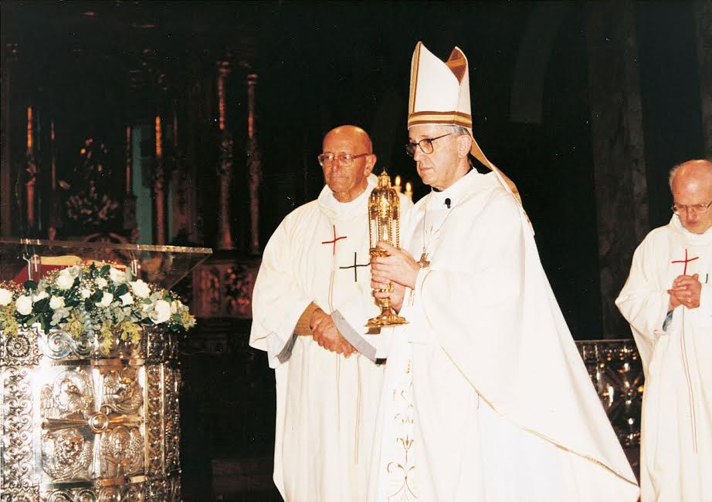
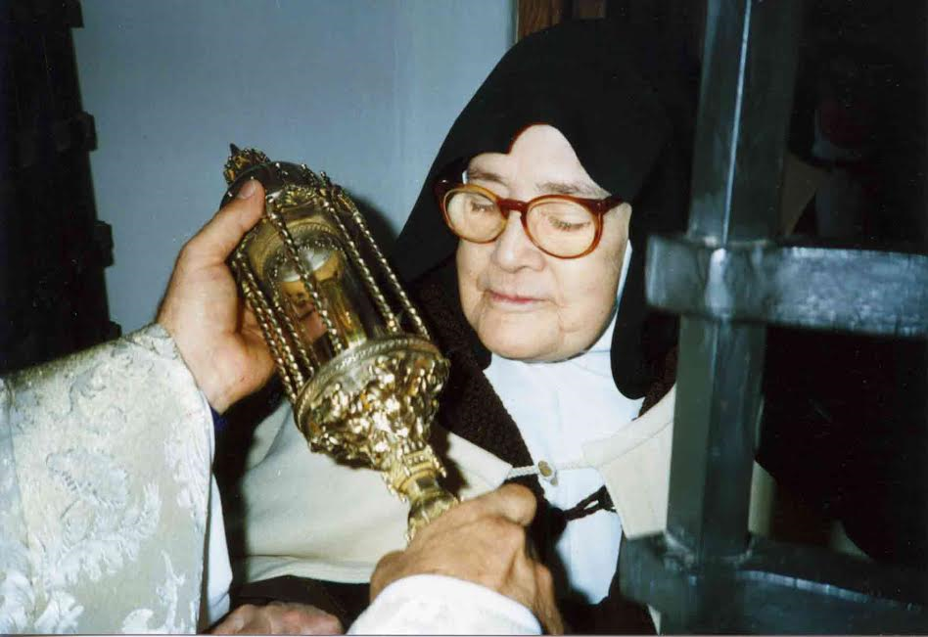

Holy Relics of Saint Anthony of Padua Visit the Archdiocese of Denver
October 14 to October 23 As The Jubilee Year of Mercy Nears Its Closing
After successful visits to America, Canada, Europe, Asia and Australia, two first class relics of St. Anthony of Padua will return to Canada for a ten-day tour of the Archdiocese of Denver.
Father Mario Conte, OFM Conv, Executive Editor of the Messenger of Saint Anthony, will travel from the Basilica of Saint Anthony of Padua, in Padua, Italy, with two relics of the beloved saint. One reliquary contains the floating rib of Saint Anthony and the other reliquary contains layers of the saint’s skin. One of the two reliquaries is highly blessed because of its association with Pope Francis and Suor Lucia of Fatima, both of whom received the holy relic for a special blessing.
St. Anthony died on June 13 in 1231, and was buried in a little church outside the walls of the town of Padua. In 1263, his remains were transferred to the newly constructed Basilica. Present at this ceremony was St. Bonaventure in his role as Minister General of the Friars Minor. When St. Anthony’s coffin was opened in St. Bonaventure’s presence, bones and ashes were found. However, the Saint’s vocal apparatus was found to be intact, and in particular, his tongue was still red and soft. At the sight of the miracle, St. Bonaventure exclaimed in awe: “Oh blessed tongue, that ever praised the Lord, and led others to praise Him! Now it is clear how great are your merits before God!” According to the Gregorian calendar, June 13, 1231, was a Friday. Saint Anthony was buried the following Tuesday, June 17, 1231, at Santa Maria Mater Domini. It is for this reason why the nine (9) day and thirteen (13) day Saint Anthony novenas are always recited on a Tuesday.
Saint Anthony of Padua is known to millions of Catholics for ‘lost items’. Catholics worldwide ask why he is associated with them. Father Mario Conte provides answers and explanations about the saint to the devotees in the English-speaking world. “Saint Anthony’s reputation as a finder of lost things dates to an incident in the saint’s life. As the legend goes, a novice who had grown tired of religious life decided to leave the Franciscan community. But before leaving, the novice took Saint Anthony’s psalter. The book was very important to Anthony, especially since it was before the printing press had been invented. The psalter had notes and comments he made in teaching his students in the Franciscan order. Anthony prayed that the psalter would be found and returned to him. Anthony’s prayers were answered: The novice returned the psalter and returned to the order.” We invite you to come and ask for Saint Anthony’s intercession for more than the loss of material things, but also for those who have lost peace of mind or who have lost a sense of direction. We will pray for his help that we might truly build a just society where no one is left behind, forgotten or lost.
In an address in Cologne, Germany, Thursday, August 18, 2005, Pope Benedict Emeritus said of relics “By inviting us to venerate the mortal remains of the martyrs and saints, the Church does not forget that, in the end, these are indeed just human bones, but they are bones that belonged to individuals touched by the living power of God. The relics of the saints are traces of that invisible but real presence which sheds light upon the shadows of the world and reveals the Kingdom of Heaven in our midst.”
The Denver Parishes will welcome the relics of their dear friend and lifelong intercessor, Saint Anthony of Padua. There will be ten (10) glorious days of masses, veneration, novenas, devotions and prayer. Prayer petitions will be distributed by Fr. Mario and his staff to allow parishioners to write their prayer petition to the saint. Father Mario will bring the petitions back to the Basilica in Padua and place them at the tomb of Saint Anthony. The tour officially ends back at the tomb where the Friars will gather and offer prayers for our intentions.

Friday, October 14
St. Rafka Maronite Church
2301 Wadsworth Blvd, Lakewood, CO 80214
720.833.0354
Veneration: 4 PM until 9 PM
Mass: 6:30 PM
Pastor: Father Andre Mahanna

Saturday, October 15
St. Anthony of Padua Catholic Church
3801 W Ohio Ave, Denver, CO 80219
303.935.2431
Veneration: Begins at 12 Noon until 8 PM
Mass: 6 PM
Pastor: Rev. Wojciech Gierasimczyk

Sunday, October 16
St. Michael The Archangel Catholic Parish
19099 E Floyd Ave, Aurora, CO 80013
303.690.6797
Veneration: Before and after each mass
Mass times: 7:00 AM, 8:45 AM, 10:30 AM, 12:30 PM, and 2:30 PM (Spanish).
Pastor: Father Terry Kissell

Monday, October 17
St. James Catholic Church
1311 Oneida St., Denver, CO 80220
303.322.7449
Veneration: 8 AM to 6 PM
Mass times: 8:15 AM and 12:10 PM
Pastor: Father Jesus Garcia

Tuesday, October 18
All Souls Catholic Parish
4950 S Logan St, Englewood, CO 80113
303.789.0007
Veneration: 8 AM to 8 PM
Mass times: 8:15 Am, 12 Noon & 7 PM
Pastor: Father Sam Morehead

Wednesday, October 19
St. Elizabeth of Hungary
1060 St Francis Way, Denver, CO 80204
303.534.4014
Veneration: 10 AM to 3 PM
Mass time: 12 Noon
Pastor: Father Ron Cattany

Thursday, October 20
St. Elizabeth of Hungary
1060 St Francis Way, Denver, CO 80204
303.534.4014
Veneration: 10 AM to 3 PM
Mass time: 12 Noon
Pastor: Father Ron Cattany

Friday, October 21
Cathedral Basilica of the Immaculate Conception
1530 Logan St, Denver, CO 80203
303.831.7010
Veneration: 10 AM to 7 PM
Mass times: 12:10 PM & 5:30 PM
Pastor: Father Ron Cattany

Saturday, October 22
Cathedral Basilica of the Immaculate Conception
1530 Logan St, Denver, CO 80203
303.831.7010
Veneration: 3 PM to 6 PM
Mass time: 4:30 PM
Pastor: Father Ron Cattany

Sunday, October 23
Cathedral Basilica of the Immaculate Conception
1530 Logan St, Denver, CO 80203
303.831.7010
Veneration: 8 AM to 8 PM
Mass time: 8:30 AM, 10:30 AM, 12:30 AM & 6:30 PM
Pastor: Father Ron Cattany

