The World's Perception of Marriage and Sexuality
We have all witnessed the rapidly declining perception of the sacredness of marriage and sexuality in our culture, as "public opinion" and ensuing legislation continue to undermine the understanding of marriage as a sacred relationship between a man and a woman that reflects the nature of Christ's relationship with His bride, the church. Likewise, the world's view of sexuality and sexual intimacy promotes the notion that neither gender nor commitment are important, but sex is a merely human pleasure that should be available to all, without restriction or consequence. As a result, infidelity, pornography, divorce, cohabitation, same-sex unions, contraception, and abortion of unwanted children are accepted as "normal", and as "rights" for all.
Couples who have made the commitment to marry in the church have a need and a right to learn a much different understanding of the Sacrament of Marriage and human sexuality as a wonderful gift that invites them into a taste of the divine love that God shares with us.
In our experience over decades of preparing couples for marriage, we have witnessed a clear decline in their understanding of the sacredness of sexuality, as they have been more and more influenced by the rapid decline of our society's understanding and appreciation of the meaning of sexuality. Several factors are obvious in the population of engaged couples: they are, on the average, approaching marriage at a later age; a great majority are cohabiting¹; and it is apparent that very few are marrying their first sexual partner ². Given that many, perhaps most, have already experienced sexual intimacy outside of the context of marriage, our challenge is to help these couples grow into a richer and more complete appreciation of what a couple’s sexual intimacy can be in marriage.
In the initial meeting with engaged couples, our fundamental role in to introduce them to a new way of understanding their sexuality so that they are at least curious, if not yet fully open, to what they will hear in the course of their marriage preparation, from the Theology of the Body. It is not the intent, at this point, to "teach" them the Theology of the Body. It is to invite them into an openness to learn something surprisingly positive and exciting about married love. Once they are open to understanding the amazing state of life God has called them to, and are willing to accept that the world's plan is counterfeit, and God's plan is beautiful, they will learn through Theology of the Body, why their sexual relationship is holy, positive, and life-giving. Then, in turn, they can discover why lust, in all its forms (infidelity, pornography, contraception, etc.) are deceptions of the enemy to cheat them of the grace, and destroy the sacredness, of their marriage.

^{1.} http://www.foryourmarriage.org/factsfigures/; http://www.usccb.org/issues-and-action/marriage-and-family/marriage/upload/Marriage-and-Family-in-the-US.pdf
^{2.} http://waitingtillmarriage.org/4-cool-statistics-about-abstinence-in-the-usa/
Presenting God's Plan to the Engaged
This is no small task, but a tremendously important one if we are to renew the world through the church, through the family, through authentically married couples and authentically celibate persons. Pope Saint John Paul II's work, the Theology of the Body presents a definitive and life-giving explanation of authentic humanity, which is most clearly defined in our sexuality…the masculinity and femininity with which God created us in His own image.
If we, as marriage preparation ministers, are to effectively transmit this life-giving message to those who are about to enter Matrimony, we must first understand and embrace this teaching ourselves. Theology of the Body (a compilation of 129 brief audiences Pope John Paul II gave from 1979 to 1984, expressing work he had written before he became pope) is a deep and profound teaching, not readily digested in one reading. So, before attempting to "introduce" this theology, we must first become familiar with it, and live it ourselves. (List of suggested resources is attached.)
Fundamental truths in Theology of the Body which are important to introduce to the engaged from the beginning.
- First is the very positive attitude that the church holds toward sex and sexuality ("correcting" the too common misperceptions that sex is bad, dirty, or primarily for procreation.) John Paul II demonstrates, that, "from the beginning," God intended to reveal his own nature through creating us as sexual persons, ordered toward relationship and self-giving.
- Unlike animals, who use their bodies instinctively to reproduce sexually, humans are uniquely created with body and spirit, and infused with a deep desire for community, as Adam discovered when he was first alone.
- God asks us to love one another as "persons", rather than use one another as "objects", particularly in the intimate love of marriage. Husbands and wives are to be in awe of each other, recognizing that they have been called by God to love this unique person they have chosen to marry.
- God is not limited to a physical body, but chose to enter into flesh to "meet us where we are," in the body. Christ's embrace of the flesh, and His clear call to return to "the beginning", before sin, to understand our human sexuality, and in that, understand more deeply God's nature and love, invites us into a deeper experience of it with Him.
- Their own marriage, as a sacrament, is a vocation to be a model of Christ's love for his church…pointing to the ultimate relationship of total love we will experience in heaven.
Appendix 1: Theology of the Body Resources
(underlined references are active hyperlinks)

Original text of the 129 talks given by Pope St John Paul II Sep 1979 - Nov 1984 http://www.ewtn.com/library/papaldoc/jp2tbind.htm

Theology of the Body in Simple Language , Pope John Paul II, 2009
http://www.amazon.com/gp/product/B00H3T9KWU

Christopher West - Theology of the Body
Theology of the Body for Beginners, Christopher West, Ascension Press, 2009
http://www.amazon.com/Theology-Body-Beginners-Introduction-Revolution/dp/1934217859/ref=sr_1_1?s=books&ie=UTF8&qid=1435719148&sr=1-1&keywords=theology+of+the+body+for+beginners

Christopher West - Introduction (youtube video 7:15)
https://www.youtube.com/watch?v=dUfTbBi1K0Q

Constance Hull (testimony and excellent summary)
http://catholicexchange.com/theology-of-the-body-changed-my-life?mc_cid=68f155e7f1&mc_eid=5202a8ebd4

These Beautiful Bones: An Everyday Theology of the Body by Emily Stimpson
http://www.amazon.com/These-Beautiful-Bones-Everyday-Theology/dp/1937155153/ref=sr_1_1?s=books&ie=UTF8&qid=1431535966&sr=1-1&keywords=These+Beautiful+Bones%3A+An+Everyday+Theology+of+the+Body+by+Emily+Stimpson

Theology of the Body and Marriage Prep by Fr. Thomas Loya https://www.youtube.com/watch?v=UlBOgnYiny4
theologyofthebody.net
http://youtu.be/Ba6-la-EO6o

Appendix 1: Theology of the Body Resources (cont.)

God, Sex, and the Meaning of Life Ministry
http://godsexmeaningoflife.homestead.com/THEOLOGY_OF_THE_BODY_summary.pdf

The Theology Of The Body According To St. John Paul II
By Professor John S. Grabowski, Department of Theology, Cath. Univ. of America
http://www.foryourmarriage.org/the-theology-of-the-body-according-to-pope-john-paul-ii/

Katrina Zeno (Diocese of Phoenix) https://www.youtube.com/user/tangohio

Men, Women and the Mystery of Love: Practical Insights from John Paul II's Love and Responsibility by Edward Sri
http://www.amazon.com/Men-Women-Mystery-Love-Responsibility/dp/0867168404/ref=sr_1_1?s=books&ie=UTF8&qid=1431536705&sr=11&keywords=Men%2C+Women+and+the+Mystery+of+Love%3A+Practical+Insights+from+John+Paul+II%27s+Love+and+Responsibility+by+Edward+Sri

Appendix 2 Marriage Statistics

From: http://www.foryourmarriage.org/factsfigures/
- People are getting married later in life. The median age of those married for the first time is currently 28.3 for men and 25.8 for women (National Health Statistics Report, 2012). Compare this to the numbers from 1960, when the median age was 23 for men and 20 for women (The State of Our Unions 1999, 10).
- Between 1960-2010, the number of cohabiting couples increased 17-fold. (The State of Our Unions 2011, 75)
- There has been a significant increase in the number of women presently cohabiting with a man: from 3% in 1982 to 11% in 2006-2010. (National Health Statistics Report, 2012)
- “Among women, 68% of unions formed in 1997-2001 began as a cohabitation rather than as a marriage.” (National Health Statistics Report, 2012)

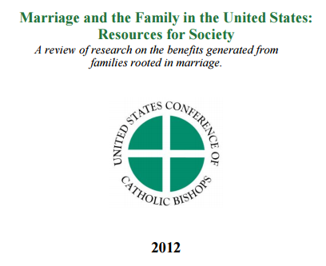

Click here to go to document

MEDIAN AGE AT FIRST MARRIAGE COHABITING COUPLES AS A PERCENT OF ALL CORESIDENTIAL COUPLES
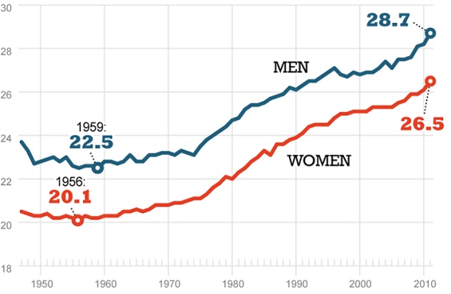
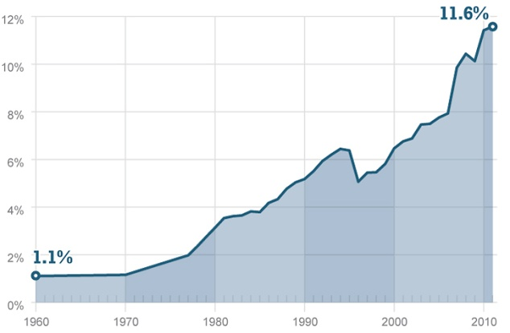

Since the 1960s, men and women have been increasingly marrying later. The median age at first marriage has risen to nearly 29 years for men and to more than 26 years for women.
The percentage of unmarried couples living together has increased ten-fold, from slightly more than one percent of all couples in 1960 to nearly 12 percent in 2011.

Source: U.S. Census Bureau, Current Population Survey, 2011.

About 3% of Americans wait until marriage to have sex (successfully)
In highly religious groups, up to 20% wait until marriage successfully

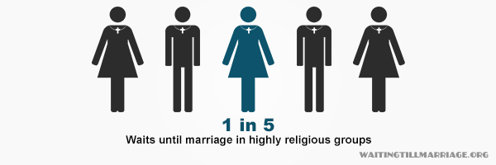

Source: Waiting till marriage.org

Appendix 3
What follows below is an example of how one might attempt to introduce the engaged couple to the concepts and teaching of Theology of the Body This is not intended as a "script" to be presented, but one approach that might be developed in your own style.
God reveals Himself through creation, especially human beings
Our faith tells us that we can discover a glimpse of our Creator through studying His creation. Just as a meadow of wildflowers, a spectacular sunset or a newborn baby fills us with awe at the beauty of creation, our own bodyliness…our masculinity and femininity, our very sexuality, is a reflection of who God is and how He loves us!
Natural law
And natural law tells us that if we act honestly, in harmony with the truth revealed in creation, our actions are moral (holy), but if we act in opposition to creation, denying the truths it reveals, our actions are immoral (potentially sinful).
We human beings have been given many unique faculties, or abilities, that God did not give to other species, and he gave us the freedom to either use these gifts as their nature intends, or to abuse them in opposition to their nature.
For example, we have been given the faculty of speech…communicating with words formed and expressed by our bodies. It is clearly the intended nature of speech to tell the truth (otherwise all speech would be meaningless, as we could not trust what was said.) And we can choose to abuse that gift by speaking falsely (lying) to deceive another person. But our bodies are so "wired" to follow the nature God has imprinted in this gift that we involuntarily try to block a lie from leaving our mouth (the "lump" in our throat as it tries to keep the lie from being spoken) and we exhibit involuntary physiological changes that can be measured by a "lie detector" device!
Three truths revealed in the nature of sex
So it is with the nature of sex. We can clearly observe three dimensions that are undeniably contained in the nature of sexual intercourse. First, it is procreative…it is the natural way that new human life is formed. (It could have been a stork; it could have been a cabbage leaf) but God created sex as the way to reproduce human beings.
Second, sexual intercourse is unifying, or bonding of the persons. Studies have shown that the same hormone, oxytocin, which causes a mother to bond with her baby in childbirth and nursing, is released in both partners in sex. Perhaps this is why premarital sex can often lead to the wrong choice of a partner, as the "super glue" of married relationship, which God intended to help marriages through the good times and the bad, can blind a person who is not yet in the totally committed, permanent, self-giving relationship of marriage to the warning signs of a bad decision.
And third, less spoken of from the pulpit, but just as much in the nature of sex, God intended sex to be uniquely physically pleasurable. This is certainly evident in our pleasure-seeking society where sex is a form of recreation, in even the most casual relationships, and even prostitution. So, if the nature of sex and sexual intercourse is at once procreative, bonding, and pleasurable, that is clearly what God intended. But, like all other gifts, we can abuse it by ignoring, denying, or tampering with the truth revealed in its proper nature.
Honoring the truth of the nature of sex
For example, if a couple chooses to enjoy the pleasures of sex, with no attempt to prevent it from being procreative, but they have no intent or desire for their sexual encounter to bond them for life…they have not entered the permanent, self-giving, unconditional relationship of marriage…they are clearly acting selfishly, and thus immorally.
And if a married couple, who desires their sexual relationship to unify and bond them, have sex with no attempt to deny the possibility of conception, but one or the other (or both) selfishly seek their own pleasure, using their partner as an object to achieve their own satisfaction (lust) rather than a total self-giving to the other as person (spousal love), it is immoral.
And finally, if a married couple, intending to strengthen their bonded relationship, give and receive the pleasures of sex together, choose to prevent the possibility of new life resulting from their intercourse (by using contraception) they are withholding from each other the essential element of fruitfulness which completes the nature of their sexual relationship.
Lying with our bodies is Lust, not Love
Like the gift of speech, sex is a form of communication, created to express total commitment, unselfish giving to another, for the transmission of life. When we deny, or contradict, or eliminate any part of the language of sex as God created it, we have been duped into settling for lust, rather than love. We can lie with our bodies even more profoundly than with our voices.
It is only in a free, faithful, and fruitful giving of self to another that we truly experience love as the divine language God created for us. Thus, fully and properly understanding the God-given nature of sex and sexuality is essential to experiencing the fullness of this gift, and avoiding a counterfeit experience which leads us away from God. We should always be striving to be more honest with our bodies to fully experience God's plan for our true joy.
What about family planning?
So, are we then just expected to have as many children as possible? Does that mean we have no ability to plan and space our family? No, the church teaches (in Humanae Vitae) that, "responsible parenthood is exercised by those who prudently and generously decide to have more children, and by those who, for serious reasons and with due respect to moral precepts, decide not to have additional children for either a certain or indefinite period of time.” (HV 10)
Thus, if there are serious and unselfish reasons to avoid pregnancy without foregoing the other gifts of marital sex, married couples may take advantage of the natural cycles of fertility readily observable in the woman's body, and limit intercourse to those times that are infertile, "thus controlling birth in a way which does not in the least offend the moral principles...” (HV 16)
Serious and unselfish reasons to avoid pregnancy
Consider, for example, a couple with three children in diapers, mom at her wits' end, dad working two jobs to keep food on the table…would it be prudent and responsible for them to decide to have another child at that time? Probably not, although if they did become pregnant, they should rejoice in this new life, trusting that God will provide what they need.
But consider a young couple, married five years, and still not "ready" to start a family because kids are expensive and a hassle, and they want to go to Europe next summer and pick up a new BMW! Would that fit the test of "serious and unselfish reasons"? Not so much…
So, when serious and unselfish reasons exist, a couple can use the natural cycle of fertility to continue to enjoy the (much needed) graces of their sexual relationship, while practicing abstinence (with its own gifts) during fertile times to avoid pregnancy until their situation has changed.
Natural Family Planning
Again, God has given us freedom to choose, and the means to be responsible parents. The course on Natural Family Planning, which you will take with your preparation for matrimony, will teach you the readily understandable, and highly reliable tools for either avoiding, or achieving pregnancy naturally…avoiding all the physical and moral pitfalls of contraception, and working with, not against , the nature of sexuality.

God's nature (community of love in Trinity) revealed in marriage
But even more profoundly, God made us sexual beings not just for bonding, procreation, and pleasure, but to reveal to us His own nature… a community of three distinct persons living in an eternal relationship of love, from which all life flows. It is through our bodies that we experience this taste of divinity…the call and ability to give ourselves fully, as person, to another person.
We are persons, not objects
How can this be, as God is not a sexual being, but a pure spirit? Well, first of all, God chose to take on human flesh in the person of Jesus Christ, to "meet us where we are" in a human body.
We are each created uniquely as a person, with emotions, needs and desires expressed in different but complementary ways in our masculinity or femininity. Within both is the desire for relationship…to love and to be loved. This, primarily, is a taste of God's own nature.
"From the beginning…"
Jesus, in speaking on divorce, reminds us that in the beginning, when Adam discovered his need for relationship with another person (none of the animals he named had a soul like him) God said it was not good for Adam to be alone and created woman as his partner. (Gen 2:18) Adam and Eve were created in His image, male and female, and before they turned away from God in sin, they were naked but felt no shame. (Gen 2:25)
Only after the fall, they became ashamed their nakedness, using fig leaves to cover their bodies. Thus began humankind's departure from what God had intended from the beginning…that man and woman would share in perfect, unselfish, open, self-giving intimacy with each other. When sin entered the picture, as the serpent seduced Adam and Eve to seek their own will rather than God's, all became distorted, and human hearts were hardened to God's original plan. We, too, have been seduced by a society and a culture that worships the idol (sex) rather than the truth (God's love imprinted in our sexual nature.)

Called to return to the truth of our humanness
Jesus calls us, especially in marriage, to return to God's plan for our human sexuality, to turn away from our convoluted seeking of love by using some thing or some person for my own needs and desires, which is a counterfeit of love, called lust.
Jesus himself gives us the model for true spousal love, a complete self-giving to the other, for the other, not for self, on the cross, in the Eucharist, and in his relationship with us, his Bride, his Church.

Called to love as Jesus loves us
Jesus' command to us is clear: "Love one another as I have loved you" (Jn 15:12)
And just how does Christ express His love for us?
- Freely ("No one takes my life from me, I lay it down of my own accord," Jn 10:18)
- Totally, without condition or reservation ("He loved them to the last," Jn 13:1)
- Bodily ("This is my body, which is given for you," Lk 22:19)
- Faithfully ("I am with you always," MT 28:20)
- Fruitfully ("I came that they may have life," Jn 10:10)

As you will see in preparing for your wedding, these same qualities are in your words of consent:
- Freely ("have you come here freely?")
- Totally ("..and without reservation?")
- Bodily ("…to give yourselves to each other")
- Faithfully ("Will you love and honor each other as man and wife for the rest of your lives?")
- Fruitfully ("Will you accept children lovingly from God…?")
So, Matrimony is the Sacrament not just of the couple's witness to God's love within them, but, as St. Paul says, "a great mystery, and I mean in reference to Christ and His Church." (Eph 5:32)
Jesus calls all of us to look back to "the beginning", before Adam and Eve were seduced away from their free, open, unashamed experience of God's love in their own bodies, and discover that we, too, have been seduced into a counterfeit understanding of our sexuality which limits our ability give and receive spousal love, with our partner, and with God.
What does this imply about how we are living before marriage?
If, at this point, you feel uncomfortable considering that God's plan for your life and for your relationship with your fiancé, may be very different from how you are living today, do not be afraid! Remember, Jesus came not to condemn, but to save. Acknowledging that I have sinned opens my heart to the healing grace of Jesus' words to the woman caught in adultery…"neither do I condemn you…go, and sin no more." (Jn 8:10)
As the prophet Joel quotes God, "return to me, with all your heart," (Joel 2:12).
Don't hesitate to seek God's forgiveness in the Sacrament of Reconciliation, especially as you prepare to embark on the Sacrament of Matrimony!
A new beginning
Let this time of preparation for marriage be a new beginning for you…an opportunity to explore and discover just how much more wonderful and blessed your lives can become as husband and wife.
There is much to learn about marriage, and sexuality, and as God said, it is all very good! (Gen 1:31)

