Guest Column

Proposition 106 asks Colorado voters to legalize Physician Assisted Suicide for people dying of a terminal illness.

Being a physician, when I listen to the stories of those who support this proposal, my heart breaks. The request for a legal means to end suffering for dying loved ones is gut-wrenching and compelling – but it comes at a price.

When a law leaves the Governor’s desk, it takes on a life of its own. Good intentions give way over time to unintended consequences. The wise voter will ask not what this law looks like the year it is passed, but rather, what its effect will be a generation from now. Thirty years ago, when the Netherlands debated this very same issue, could they have imagined that, within one generation, Dutch doctors would be euthanizing elderly suffering from loneliness, babies with birth defects, and teenagers with Autism? *

I provide medical care to the medically indigent patients of Weld County. Many are uninsured and the majority have Medicaid. I often struggle to get approval for testing and treatment for my patients. Do you fear that, as has already happened in Oregon, our financially burdened health care system will see assisted suicide as a less expensive alternative to more costly treatment options?

Over the years, I have seen families torn apart fighting over inheritances. With the availability of assisted suicide, do you fear that our more vulnerable elderly might be subtly pressured or manipulated into accepting that option?

The idea of controlling how and when we die is very attractive at first glance. It is a difficult thing to deny oneself that freedom for the sake of the greater good and for the protection of the poor, the vulnerable and the disabled. But true autonomy is not freedom to do what we want, but rather freedom to do what is right.

When a culture embraces death as the solution to a problem, we change. It hardens us. We become more casual and calloused about life and death. Dutch ethicist Theo Bohr laments that this exaggerated sense of autonomy “seems to have overruled other values like solidarity, patience, making the best of things.” Our ability to endure suffering and trials becomes weakened.

The slope between Colorado and the Netherlands is slippery – but not steep. It is subtle and gradual. Once we choose to embark upon this path, there is no turning back. Let us be wise as we consider this most important issue.

John Volk, MD
Greeley

* “Dying Dutch: Euthanasia Spreads Across Europe,” Newsweek, February 20, 2015
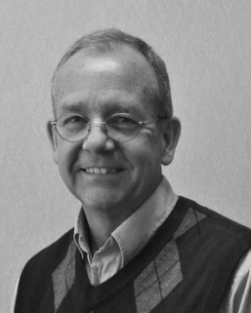

John Volk, MD
Family Physician
Greeley

